**LAB 5 : Imaging QEMU with Build Appliance**

**Group members:-** Shahrukh Padaniya

Rohan Yadav

Swapnil Sewak

Step-1:- Download **Build Appliance - Gatesgarth 3.2.1** from the website given below and extract the file. We will have three files in the extracted folder.

Download link - <https://www.yoctoproject.org/software-overview/downloads/>

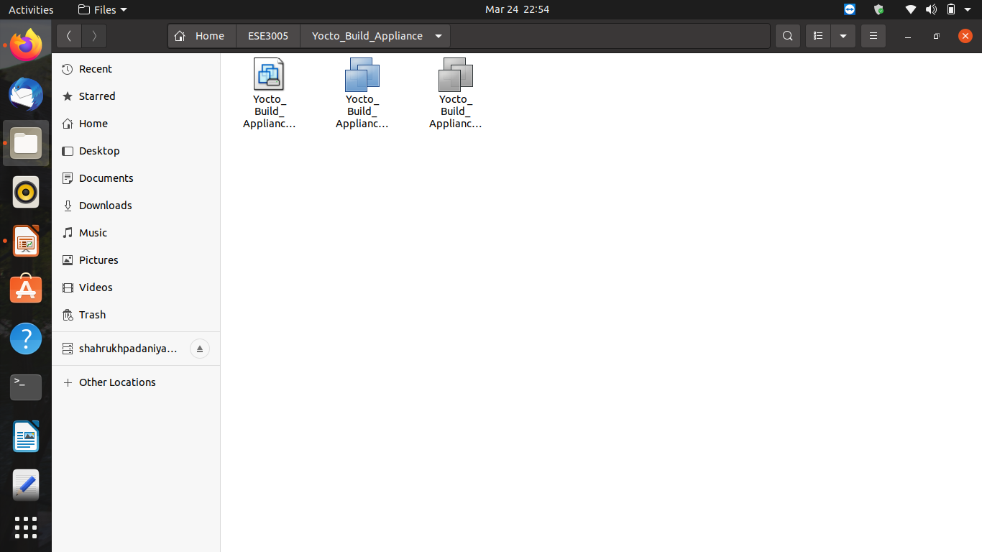

Step-2:- Download **VMware Workstation 16.1.0** Pro for Linux from the website given below.

Download link:- <https://my.vmware.com/en/web/vmware/downloads/details?downloadGroup=WKST-1610-LX&productId=1038&rPId=55778>

After downloading open terminal and type following command to install vmware workstation.

sudo sh VMware-Player-16.1.0-17198959.x86_64.bundle

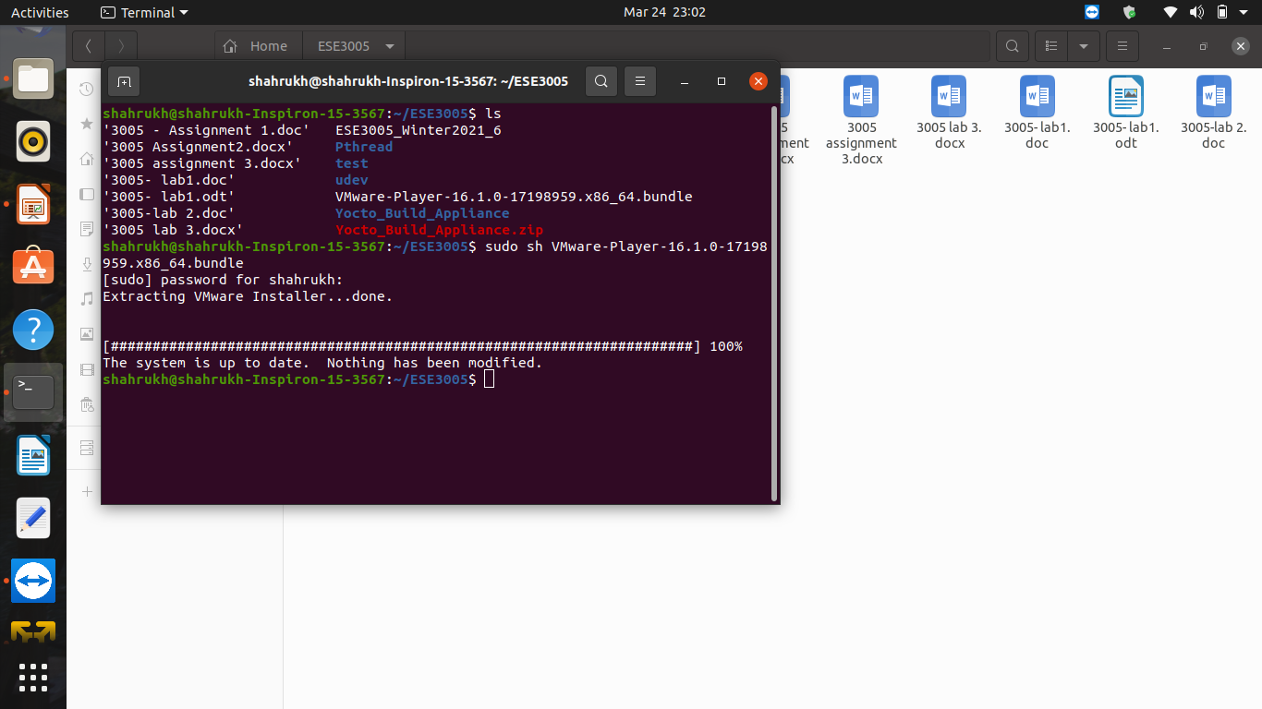

Step 3:- Open VMware-Player-16.1.0-17198959.x86 and click on open a virtual machine. After this select Yocto_Build_Appliance.vmx file from Yocto_Build_Appliance folder.

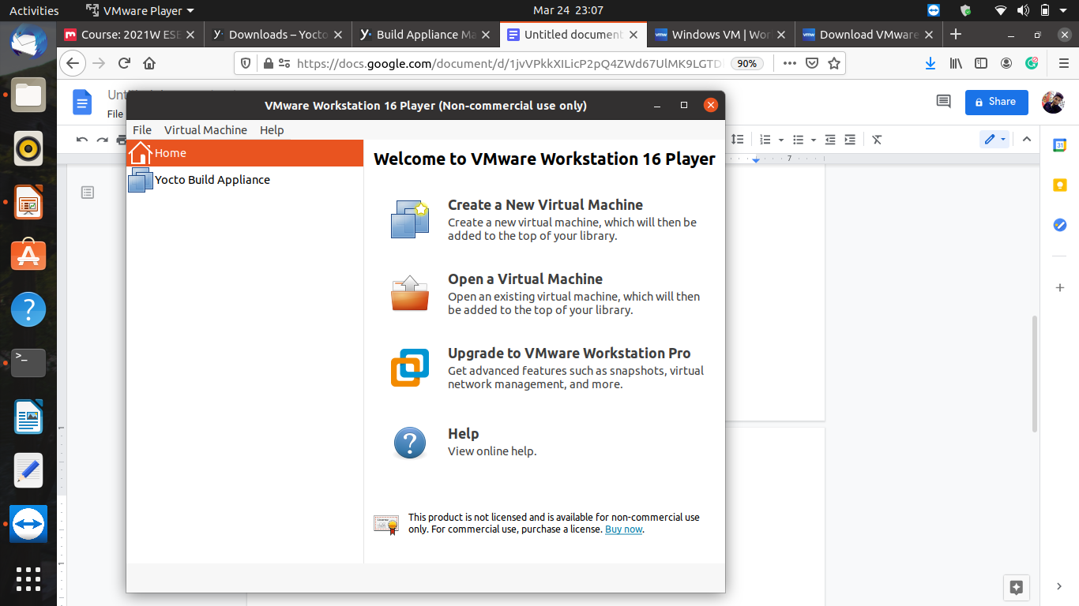

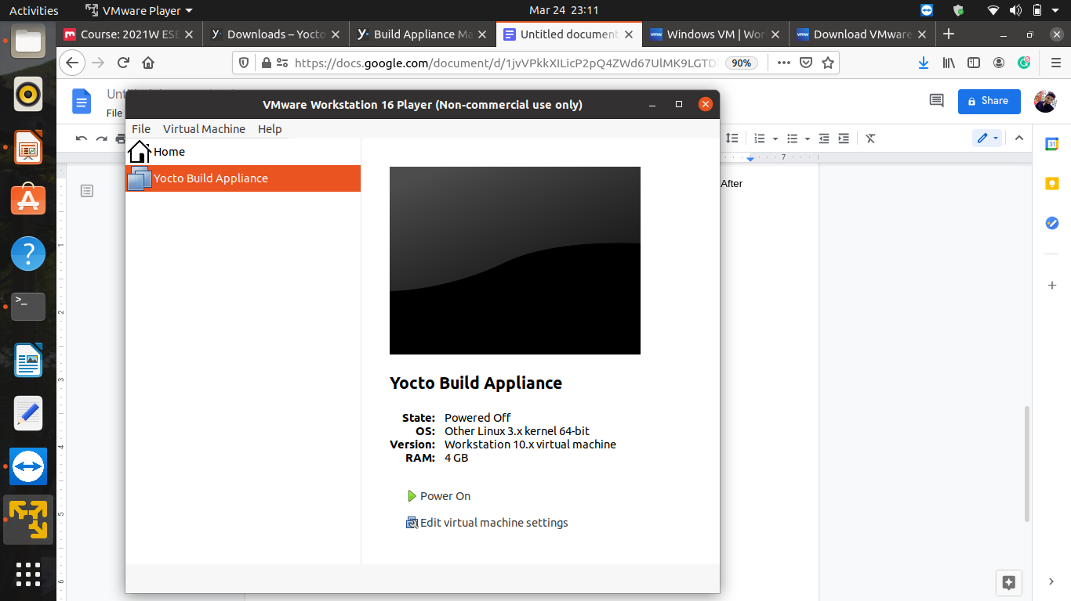

Step 4:- Power on and if it asks for a username or login enter root.

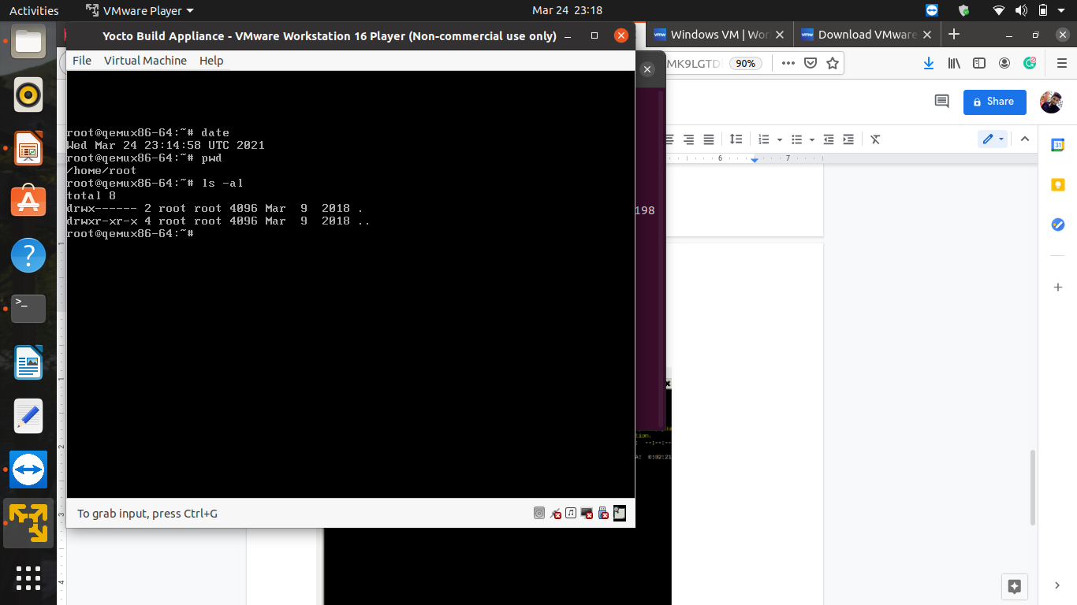

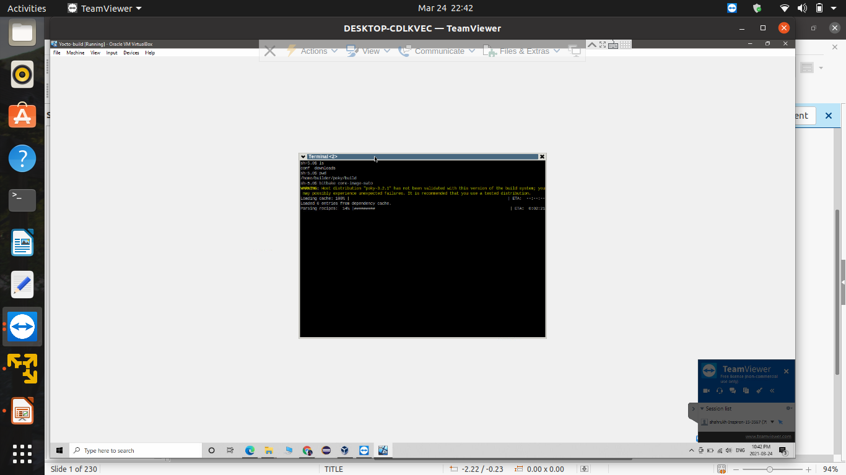

Reference:-

https://old.yoctoproject.org/documentation/build-appliance-manual

https://www.yoctoproject.org/software-overview/downloads/